VisionStick
Real-Time Obstacle Detection, Tracking, Depth Estimation, and Audio Navigation for Visually Impaired Users

Computer Vision — Final Project Report
Saint Joseph University | Spring 2026

Presented By: Naji Bou Zeid (231833), Mathieu Moussa (231284),
Michel Abou Rahal (230952)

Instructor: Dr. Ahmad Audi

Date: Friday, May 15, 2026

Table of Contents
1. Introduction 2
1.1 Problem & Motivation 2
1.2 Related Work 3
2. Dataset 3
2.1 COCO Dataset 3
2.2 Custom Dataset for Transfer Learning (Open Images V7) 4
2.3 Tracking Benchmarks4
2.4 Depth Estimation Training Data 5
3. Methodology 6
3.1 System Overview 6
3.2 Dual YOLOv8 Object Detection7
3.3 Multi-Object Tracking with ByteTrack 7
3.4 Monocular Depth Estimation 7
3.5 Hybrid Closeness Score 8
3.6 Zone Classification 8
3.7 Risk Scoring 8
3.8 Temporal Trend Detection 9
3.9 Audio Alert System 9
4. Experiments & Results 10
4.1 Transfer Learning — Training Results 10
Training Dynamics 10
Validation Metrics 11
Precision-Confidence Curve 11
Recall-Confidence Curve 12
Confusion Matrix 13
5. Discussion 14
6. Conclusion 15
7. References 15

1. Introduction

1.1 Problem & Motivation
Visual impairment significantly affects independent mobility and spatial awareness in daily life. According to the World Health Organization (WHO) [9], millions of individuals worldwide experience blindness or severe visual impairment, making safe navigation a major challenge. Traditional mobility aids such as white canes provide tactile feedback only within short range, while GPS-based systems lack detailed awareness of nearby dynamic obstacles such as pedestrians, vehicles, furniture, or street objects. As a result, visually impaired users often encounter difficulties in crowded urban environments, indoor navigation, and rapidly changing scenes.
Recent advances in Computer Vision and Deep Learning have enabled the development of assistive systems capable of understanding visual scenes in real time. Object detection architectures such as YOLO (You Only Look Once) have demonstrated high accuracy and low inference latency, making them suitable for embedded and real-time applications. In parallel, monocular depth estimation methods such as MiDaS [5] and Depth Anything [2] provide dense scene understanding from a single RGB camera without requiring stereo hardware or LiDAR sensors.
This project presents VisionStick, a real-time obstacle detection and audio navigation aid designed for visually impaired users. The system processes live video input from a webcam or camera feed and generates spoken warnings about nearby obstacles, their direction, and their motion trend (approaching or receding). The proposed pipeline combines:
- Dual YOLOv8 detection: COCO-pretrained YOLOv8s plus the custom Door/Tree/Stairs model
- ByteTrack multi-object tracking
- Depth Anything V2 monocular depth estimation
- Hybrid risk scoring and temporal reasoning
- Real-time text-to-speech (TTS) audio alerts

Unlike systems relying exclusively on object detection or raw depth estimation, VisionStick combines dual YOLO detections, relative depth, walking-path overlap, class hazard weighting, and temporal reasoning. This reduces the bias of selecting naturally large objects solely because their bounding boxes occupy more image area.

1.2 Related Work
Several prior studies have explored assistive navigation using computer vision and audio feedback. García et al. [8] demonstrated a real-time obstacle detection system for visually impaired people using deep learning on a wearable camera, establishing the viability of CNN-based approaches for mobility aid. Aladrén et al. [7] proposed an RGB-D system with range expansion for navigation assistance, but required depth sensors — an expensive and bulky hardware constraint that VisionStick avoids by using monocular estimation.
On the depth estimation side, Ranftl et al. introduced MiDaS [5], a zero-shot cross-dataset depth model that trained on mixed datasets for generalization, and later DPT [6], which applied Vision Transformers for dense prediction tasks including depth. Yang et al.'s Depth Anything V2 [2] built on this foundation to achieve state-of-the-art monocular depth quality at lightweight inference cost, making it the natural choice for a real-time embedded pipeline. On the tracking side, Zhang et al.'s ByteTrack [3] demonstrated that associating every detection box — including low-confidence ones — significantly reduces identity switches in crowded scenes, which is critical for stable audio alerts. VisionStick integrates these developments into a unified real-time pipeline that has not been combined in this specific way in prior work.

2. Dataset

2.1 COCO Dataset
The primary dataset used in this project is the Microsoft COCO (Common Objects in Context) dataset introduced by Lin et al. [4]. COCO is one of the most widely used benchmarks for object detection, segmentation, and scene understanding tasks. The dataset contains:
- Approximately 118,000 training images
- Around 5,000 validation images
- 80 object categories
- Complex scenes with multiple objects and varying lighting conditions

The YOLOv8s detector used in this project relies on pretrained weights trained on the COCO dataset. Rather than using all 80 categories, the system filters detections to a subset of 14 navigation-relevant classes: person, bicycle, car, motorcycle, bus, truck, traffic light, stop sign, chair, couch, potted plant, bed, dining table, and TV. These classes represent common obstacles or environmental structures encountered during indoor and outdoor navigation. Dynamic objects such as cars, buses, motorcycles, and bicycles are important for road safety, while indoor objects such as chairs and tables represent common collision hazards.
The dataset split strategy follows the original COCO partitioning inherited from the pretrained YOLOv8 model: training on COCO train2017, validation on COCO val2017, and qualitative evaluation on custom live video streams.

Table 1: Selected COCO Classes and Navigation Relevance

2.2 Custom Dataset for Transfer Learning (Open Images V7)
Although COCO provides strong general object recognition capability, it lacks several critical classes required for assistive navigation, including stairs, doors, and trees. A subset of the dataset Open Images V7 was used to enable transfer learning of these navigation-specific classes on top of the YOLOv8s backbone pretrained on COCO.
The subset comprises 5400 labelled images divided into three classes: Door, Tree , and Stairs. The dataset was split into 4,500 training images and 900 validation images.

2.3 Tracking Benchmarks
The tracking component used in this project relies on ByteTrack, a multi-object tracking framework evaluated and optimized using several large-scale tracking datasets commonly used in computer vision research. These datasets provide frame-by-frame annotations and object identity labels required for learning temporal object association across video sequences.
The primary datasets associated with ByteTrack include:
- MOT17
- MOT20
- CrowdHuman
- CityPersons
- ETHZ
- HiEve
MOT17 and MOT20 are widely used pedestrian tracking benchmarks containing crowded urban scenes with significant occlusion, scale variation, and object interaction. CrowdHuman focuses on dense human detection and tracking scenarios with overlapping pedestrians and challenging visibility conditions. CityPersons contains urban street environments with annotated pedestrians under varying lighting and weather conditions. ETHZ and HiEve introduce additional complexity through moving cameras, crowded public spaces, and dynamic real-world scenes.
These datasets collectively expose the tracking framework to diverse environmental conditions such as:
- motion blur
- partial occlusion
- camera motion
- varying object scales
- dense crowd interactions
- complex urban traffic scenarios
In VisionStick, the ByteTrack framework is integrated after the YOLOv8 detection stage to preserve consistent obstacle identities across consecutive frames, enabling temporal reasoning and stable obstacle awareness during navigation.

2.4 Depth Estimation Training Data
Depth Anything V2 was selected because it provides strong relative depth estimation quality while maintaining lightweight inference suitable for real-time execution. The depth estimation component used in this project is based on Depth Anything V2, a deep learning framework designed for monocular depth estimation from a single RGB image. Unlike stereo vision systems or LiDAR-based approaches, monocular depth estimation predicts scene geometry using only standard camera input, significantly reducing hardware complexity while preserving dense environmental understanding.
Depth Anything V2 was trained using a combination of large-scale synthetic labeled datasets and millions of unlabeled real-world images. The synthetic datasets provide accurate ground-truth depth supervision, while the real-world images improve generalization across diverse environmental conditions. The primary datasets used during training include:
- Hypersim
- Virtual KITTI 2
- TartanAir
- BlendedMVS
- IRS
In addition, the model leverages more than 62 million unlabeled real-world images collected from datasets such as:
- Open Images V7
- Places365
- Objects365
- ImageNet-21K
- LSUN
- SA-1B
- BDD100K
These datasets contain highly diverse indoor and outdoor environments, including urban scenes, buildings, roads, furniture, pedestrians, vegetation, and dynamic obstacles. This diversity enables Depth Anything V2 to generalize effectively across different lighting conditions, scene structures, and environmental layouts.
In VisionStick, the depth estimation model is used to generate dense relative closeness maps for each video frame. These maps provide spatial awareness information that allows the system to estimate obstacle proximity and prioritize nearby hazards during assistive navigation.

3. Methodology

3.1 System Overview
VisionStick is implemented as a 12-stage real-time computer vision pipeline organized across four Python modules: config.py (all tunable constants), core.py (all stage functions as procedural state-dict operations), pipeline.py (pipeline orchestration and async depth worker), and run.py (CLI entry point). The procedural state-dict design — rather than classes — keeps every stage independently testable and allows runtime reconfiguration without subclassing. The pipeline receives a live RGB video stream and processes it through the following stages:
- Stage 1: Video source (webcam or file)
- Stage 2/3: Dual YOLO object detection + ByteTrack multi-object tracking
- Stage 4: Asynchronous monocular depth estimation
- Stage 5: Depth-heavy closeness and walking-path relevance computation
- Stage 6: Per-track EMA depth smoothing
- Stage 7: Risk scoring, class-specific adjustment, and ranking
- Stage 8: Primary obstacle selection
- Stage 9: Temporal trend tracking
- Stage 10: Alert decision engine
- Stage 11: TTS audio output (Windows SAPI via PowerShell)

3.2 Dual YOLOv8 Object Detection
This stage identifies important objects in the scene using two YOLOv8 models running on the same input frame. The COCO-pretrained YOLOv8s model detects the selected general navigation classes such as people, vehicles, chairs, and traffic objects, while the custom fine-tuned model detects the additional Door, Tree, and Stairs classes.
The detection stage uses the Ultralytics implementation of YOLOv8. The baseline detector is yolov8s.pt pretrained on COCO, and the custom detector is models/best.pt trained on Door, Tree, and Stairs. Predictions from both models are converted into the same detection format and merged at the application level before depth estimation, tracking, risk scoring, and alert selection.
- Models: yolov8s.pt and models/best.pt | Confidence threshold: 0.45 | IoU threshold: 0.45
- Inference resolution: 480 px (long edge)
- Minimum bounding-box fill: 0.3% of frame area (filters distant non-hazards)

Performance optimizations are applied at startup to both YOLO models: model layer fusion (model.fuse()) reduces redundant computation in inference, and weights are cast to FP16 half-precision on CUDA (model.half()), reducing memory bandwidth and improving throughput. Two dummy inference passes are run at startup for each detector to warm up CUDA kernels before live frames arrive.
The YOLOv8 small variant was selected for the COCO branch because it provides better detection quality than YOLOv8n while remaining faster than YOLOv8m. The custom branch is kept separate because its model only recognizes Door, Tree, and Stairs; replacing the COCO detector with it would remove the general obstacle classes. A minimum fill filter still removes extremely small detections that are unlikely to affect navigation.

3.3 Multi-Object Tracking with ByteTrack
After detecting obstacles, the system keeps track of them as they move across consecutive video frames. This allows VisionStick to understand whether an obstacle is approaching, moving away, or remaining stable, while also preventing repeated or inconsistent alerts.
The system uses ByteTrack [3] for persistent object tracking across frames. ByteTrack's key innovation is associating every detection box — including low-confidence ones — rather than discarding them. This reduces identity switches in crowded scenes and produces stable track IDs that enable temporal reasoning, approach detection, and suppression of flickering detections. A track must persist for a minimum of 3 consecutive frames (MIN_TRACK_AGE = 3) before any audio alert is generated, suppressing ghost detections from transient false positives.

3.4 Monocular Depth Estimation
This stage helps the system estimate how close obstacles are to the user using only a standard camera image. By understanding the relative distance of objects in the scene, VisionStick can prioritize nearby hazards and improve navigation awareness.
Depth estimation is performed using Depth Anything V2 Small [2] via HuggingFace Transformers. The model uses float16 on CUDA, matching the YOLO precision setting. The depth model operates in a dedicated background thread through an async worker that holds a single pending-frame slot: if a new frame is submitted while depth inference is still running, the old pending frame is silently overwritten rather than queued. This drop-if-busy design prevents queue build-up and ensures the pipeline remains non-blocking under sustained load.
Depth is re-estimated every 5 frames at a maximum resolution of 320 px (long edge), giving approximately 6 depth updates per second at 30 FPS — sufficient for walking-pace obstacle changes. The resulting depth map provides relative depth where larger values correspond to objects closer to the camera.

3.5 Hybrid Closeness Score
To improve reliability, the system combines multiple sources of spatial information to estimate how close an obstacle is. This hybrid approach provides more stable and consistent proximity estimation, especially in challenging environments or noisy visual conditions.

Bounding-box fill:
Bounding-box fill is the fraction of the image area covered by the detection (fill = bbox_area / frame_area). It remains useful as a weak proximity cue, but the final implementation avoids making it dominant because naturally large objects such as trees, cars, doors, and stairs can occupy large image regions even when they are not the immediate walking-path hazard.
Depth closeness:
Depth closeness is the median depth value sampled from the inner 60% of the bounding box, normalized by the scene's 10th–90th percentile depth range. Sampling the inner region avoids background bleed at box edges.
Final closeness formula:
closeness = 0.25 x bbox_fill_closeness + 0.75 x depth_closeness
The heavier weighting toward depth closeness (0.75) reflects the navigation goal of estimating relative proximity while reducing bounding-box-size bias. Before the first asynchronous depth map is available, the system uses a conservative fallback of 0.30 x bbox_fill_closeness + 0.70 x neutral_closeness. An Exponential Moving Average is applied per track (EMA alpha = 0.45) to reduce jitter, defined as: S_t = 0.45 x X_t + 0.55 x S_(t-1).

3.6 Zone Classification
Based on the estimated obstacle proximity, the system classifies each object into different danger zones ranging from safe to critical. This allows VisionStick to adapt the urgency of alerts according to the level of potential risk.
Obstacle urgency is mapped to one of four zones using a blended zone signal rather than bounding-box fill alone. The zone signal combines smoothed closeness and walking-path relevance: zone_signal = 0.70 x closeness + 0.30 x path_score. This prevents large objects outside the user's walking path from being over-prioritized.
The 4 zones are :
- Safe
- Medium
- High
- Critical

3.7 Risk Scoring
Each detected obstacle is assigned a risk score based on factors such as proximity, position, object type, and detection reliability. This helps the system determine which obstacle represents the most important threat at any given moment.
Each tracked obstacle receives a weighted risk score:
risk = 0.45 x closeness + 0.30 x path_score + 0.15 x hazard_weight + 0.10 x confidence
The path_score component estimates whether the object lies in the likely walking corridor. It combines horizontal centrality, overlap with the lower-middle corridor of the frame, and how far the object's lower edge reaches into the bottom of the image.
path_score = 0.55 x center_score + 0.30 x corridor_overlap + 0.15 x bottom_score
The walking corridor is defined as the central 30%-70% of the image width and the lower 35%-100% of the image height. The hazard_weight remains a per-class constant reflecting real-world danger, while class-specific adjustments reduce over-prioritization of doors, trees, vehicles, and other naturally large objects unless they are close and in the walking path. A default weight of 0.60 is applied to any class not explicitly listed.

Table 1: YOLO chosen classes
Object Class | Hazard Weight
person | 1.00
car | 0.95
bus | 0.95
truck | 0.95
bicycle | 0.90
motorcycle | 0.90
chair | 0.70
dining table | 0.70
couch | 0.65
potted plant | 0.60
tv | 0.55
bed | 0.55
traffic light | 0.50
stop sign | 0.50

The highest-risk object above a threshold of 0.25 is selected as the primary obstacle. If no object clears this threshold, no alert is generated.

3.8 Temporal Trend Detection
The system continuously observes how obstacles move over time to determine whether they are approaching, moving away, or remaining stable. This temporal understanding improves alert accuracy and helps provide more meaningful navigation feedback.
Each tracked object maintains a rolling deque of the last 6 smoothed closeness values (TREND_WINDOW = 6). To detect motion trends, the window is split into two equal halves and the mean closeness of each half is compared:
rel_change = (mean(second_half) − mean(first_half)) / mean(first_half)
If rel_change > 0.08, the object is classified as approaching. If rel_change < −0.08, it is receding; otherwise it is stable. This proportional half-window comparison is more robust than a raw frame-to-frame difference because it averages over multiple observations, suppressing noise from detection jitter. A minimum of 3 history values is required before the system attempts trend classification; otherwise, the object is treated as stable.

3.9 Audio Alert System
The audio alert system provides real-time spoken feedback to inform the user about nearby obstacles and their level of danger. Intelligent alert management is used to reduce unnecessary repetitions and ensure that urgent warnings are delivered clearly and promptly.
Audio alerts are generated using Windows SAPI through a persistent PowerShell subprocess. Speech is queued through a Python thread-safe queue with maxsize = 1, ensuring that only the most recent unspoken message is held. This freshness-over-backlog design prevents the user from hearing stale warnings about obstacles they have already passed. DANGER-zone alerts additionally flush any pending message before being queued, so they are never delayed by a lower-priority speech item.
The alert decision engine enforces zone-specific cooldowns but also implements two override triggers that bypass the cooldown entirely: (1) when the primary obstacle changes to a different tracked object (new hazard identified), and (2) when the zone of the current primary escalates to a higher urgency level (e.g., MEDIUM → CLOSE). The SAFE zone is permanently suppressed — no alert is ever generated for safe-distance objects regardless of cooldown state.

Table 2: Zone alerting cooldowns
Zone | Cooldown / Behaviour
DANGER | 1.5 s (queue flushed; overrides pending messages)
CLOSE | 3 s
MEDIUM | 5 s
SAFE | Never fires (zone suppressed in code)

The image frame is divided into three horizontal regions (left, ahead, right) to provide directional guidance. A typical alert takes the form: "Person very close ahead, approaching."

4. Experiments & Results

4.1 Transfer Learning — Training Results
To extend the system’s capability beyond COCO classes, transfer learning was performed by fine-tuning the YOLOv8s backbone on the custom Door/Tree/Stairs dataset described in Section 2.2. The pretrained COCO weights were used as initialization (yolov8s.pt), and training was conducted on Google Colab with an NVIDIA Blackwell GPU over 80 epochs using the following configuration: image size 640×640, batch size 64, 8 dataloader workers, and patience 20:
model = YOLO("yolov8s.pt") | epochs=80, imgsz=640, batch=64, patience=20

Training Dynamics
All three loss curves (box, classification, DFL) decreased smoothly across all 80 epochs for both training and validation splits, with no signs of overfitting or plateau. Precision and recall on the validation set both converged toward values above 0.90 by the final epoch, while mAP@50 and mAP@50-95 continued rising monotonically throughout training, indicating that additional epochs could further improve performance. The training loss curves and metric progression are shown in the figure below.

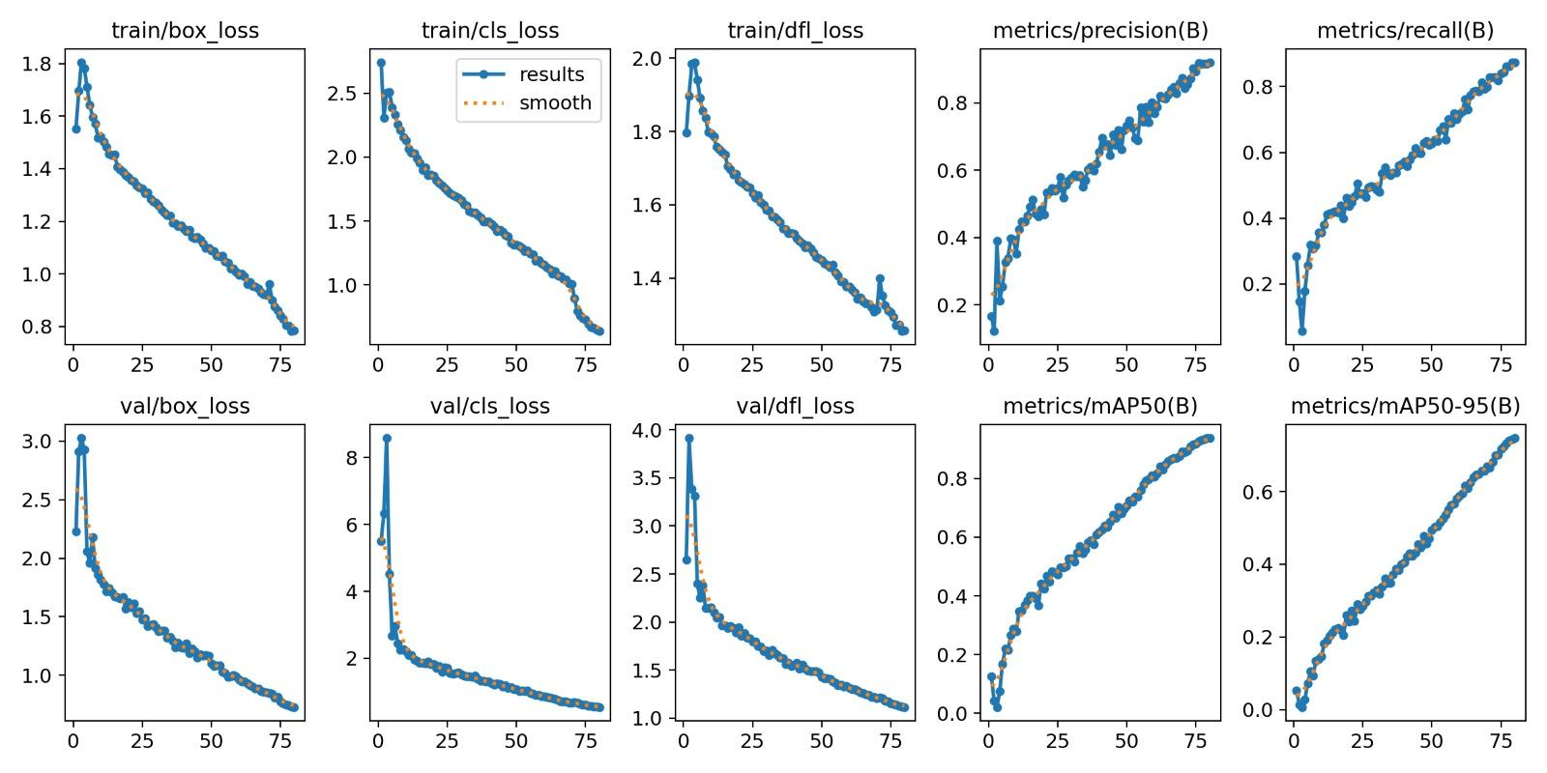
Figure 1: Training and Validation Loss Curves of the Fine-Tuned YOLO Model

Validation Metrics
Final validation results on the 900-image held-out set after 80 epochs are reported in Table 1 below. The fine-tuned model achieves strong detection performance across all three navigation-specific classes.

Table 3: Transfer Learning Validation Results (YOLOv8s fine-tuned, 80 epochs, val set: 900 images)
Class | Images | Precision | Recall | mAP@50 | mAP@50-95
All | 900 | 0.916 | 0.875 | 0.937 | 0.746
Door | 300 | 0.885 | 0.823 | 0.905 | 0.694
Tree | 301 | 0.908 | 0.864 | 0.932 | 0.696
Stairs | 299 | 0.956 | 0.938 | 0.975 | 0.847

The fine-tuned model achieves an overall mAP@50 of 0.937 and mAP@50-95 of 0.746 across all three classes. Stairs achieves the highest recall (0.938) and mAP@50 (0.975), reflecting the class’s distinctive visual pattern and high annotation consistency. Door detection is slightly lower in recall (0.823) due to significant visual variability across door styles, materials, and occlusion states. Tree obtains strong mAP@50 (0.932) but the lowest mAP@50-95 (0.696), likely due to irregular boundary shapes making tight bounding-box localization more challenging.

Precision-Confidence Curve
The precision-confidence curve (Figure 2) shows that all classes reach precision 1.00 at a confidence threshold of 0.876 for the combined model. Stairs exhibits the steepest precision rise at low confidence, indicating highly distinct features that the model learns to associate with high certainty. Door and Tree converge more gradually, consistent with their greater intra-class visual variability. For the VisionStick deployment, a confidence threshold of 0.45 is used for the custom-class model to match the COCO detector configuration, providing a practical operating point while suppressing low-confidence detections and retaining adequate recall.
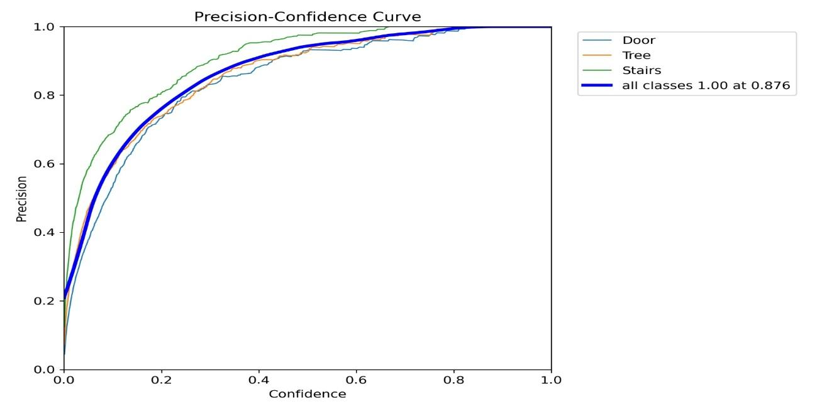
Figure 2: Precision–Confidence Curve for the new learned classes

Recall-Confidence Curve
The recall-confidence curve (Figure 3) illustrates the expected trade-off between detection confidence and recall performance. As the confidence threshold increases, recall gradually decreases because fewer detections satisfy the stricter confidence requirement. The combined model achieves an initial recall of approximately 0.98 at very low confidence thresholds, indicating strong detection coverage across the evaluated classes.
Among the individual classes, Stairs maintains the highest recall across most confidence levels, suggesting that the model consistently recognizes stair patterns even under stricter confidence filtering. Door and Tree exhibit a steeper recall decline at higher thresholds, reflecting their larger appearance variability and the increased difficulty of maintaining stable detections under diverse environmental conditions.
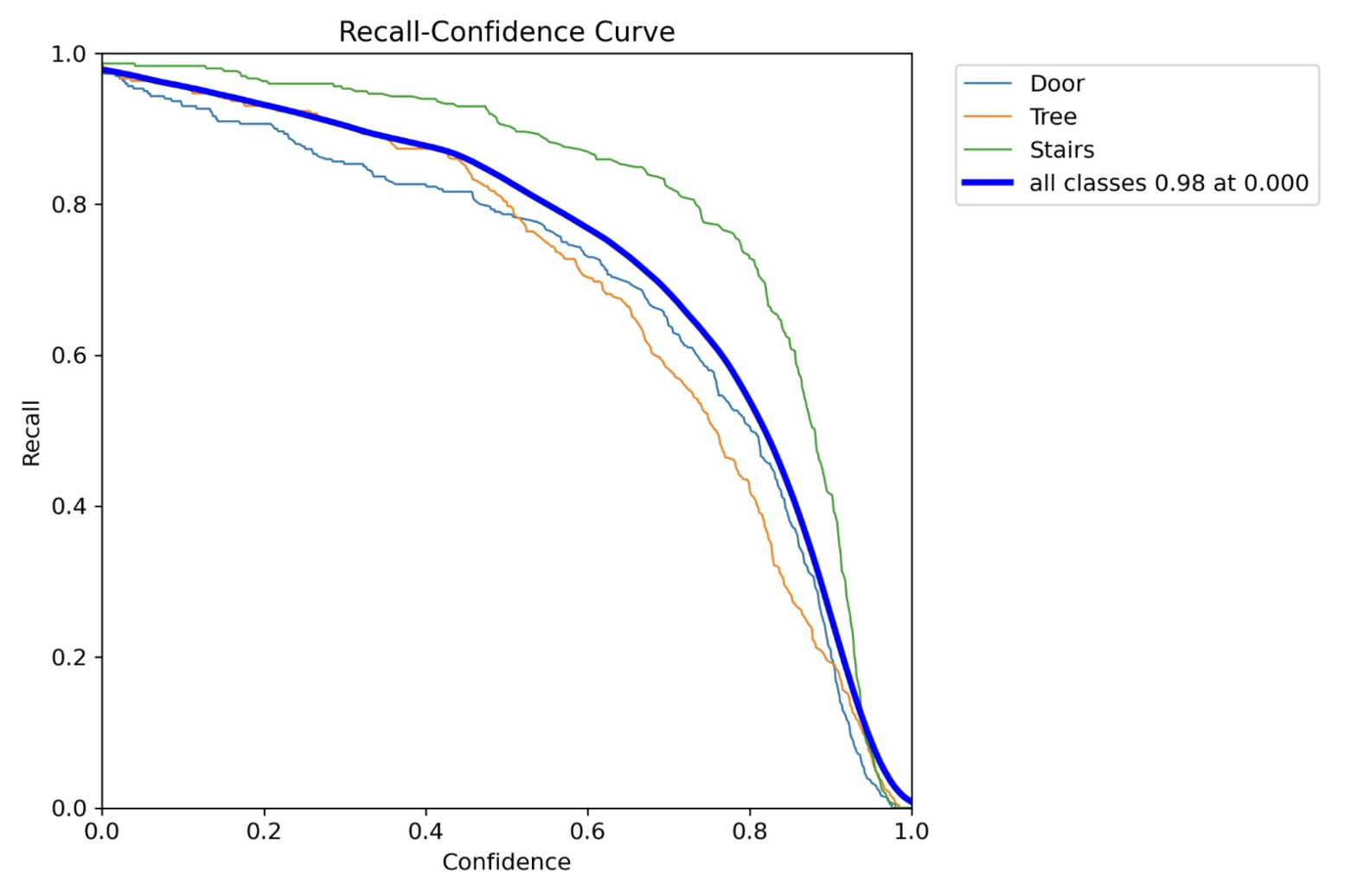
Figure 3: Recall–Confidence Curve for the new classes

Confusion Matrix
The confusion matrix (Figure 4) demonstrates strong classification performance across the three custom navigation classes, with most predictions concentrated along the main diagonal. This indicates that the transfer-learned YOLO model is capable of correctly distinguishing between Door, Tree, and Stairs with high consistency.

Among the evaluated classes, Stairs achieves the strongest classification performance, with 287 correct detections and minimal confusion with other categories. Tree also exhibits high recognition accuracy with 283 correct predictions, while Door achieves 263 correct detections. The limited off-diagonal values indicate that inter-class confusion remains low, suggesting effective feature separation between the custom obstacle categories.

Most remaining errors correspond to background-related misses rather than incorrect cross-class predictions. This behavior is preferable in assistive navigation systems because it reduces the likelihood of dangerous obstacle misclassification. Overall, the confusion matrix confirms that the transfer learning process successfully adapted the detector to recognize the newly introduced navigation-critical classes with strong reliability.
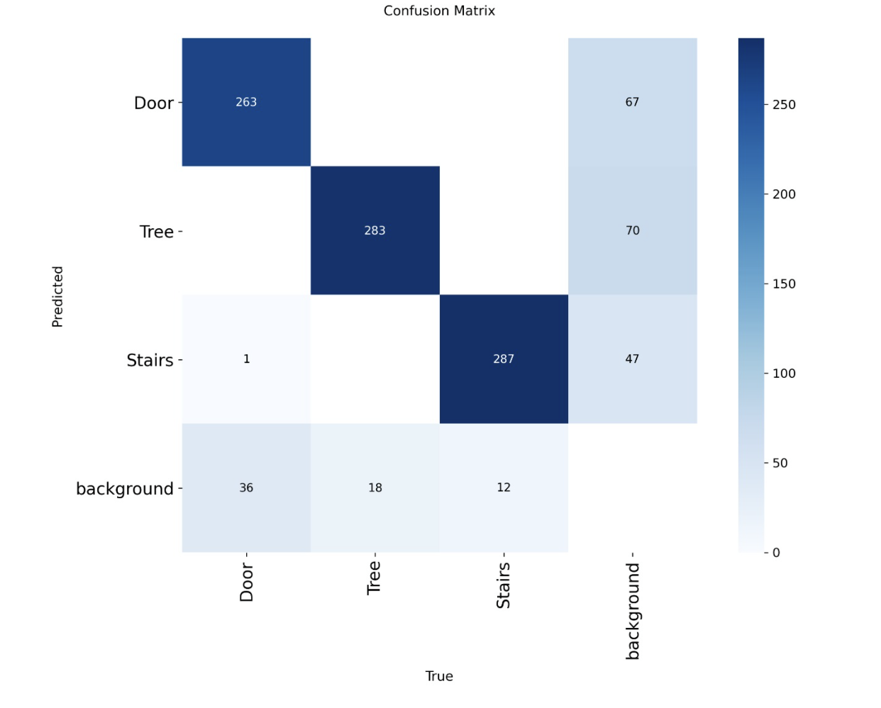
Figure 4: Confusion Matrix — Transfer Learning Evaluation for New Navigation Classes

5. Discussion

The proposed system demonstrates that a hybrid real-time computer vision pipeline can provide meaningful navigation assistance using only a monocular RGB camera. A key design refinement is that bounding-box fill is no longer treated as the dominant danger signal. Instead, VisionStick combines relative depth, walking-path overlap, class hazard weighting, confidence, and temporal smoothing so that naturally large objects do not automatically override smaller but more relevant hazards in front of the user. ByteTrack improves usability by maintaining persistent object identities, enabling temporal trend detection and suppression of ghost alerts.
The asynchronous depth architecture proved particularly important. The drop-if-busy worker design — where a new frame silently overwrites the pending slot rather than queuing — guarantees that depth inference never backs up behind the main detection loop, even under GPU contention. FP16 half-precision on both YOLO and the depth model halves memory bandwidth, allowing both models to coexist on a consumer-grade 8 GB GPU without VRAM pressure.
The alert decision engine embeds important safety engineering: two cooldown-override triggers (primary change, zone escalation), a TTS queue capped at one message for freshness, DANGER-queue flushing, and permanent SAFE-zone suppression. These mechanisms collectively prevent alert fatigue while ensuring urgent warnings are never delayed.
Several limitations remain. The transfer-learned custom model covers stairs, doors, and trees, but other navigation-critical classes such as escalators, ramps, and curbs are not yet included. Monocular depth provides only relative depth, not metric distance, so exact distance reporting is not possible. The TTS implementation depends on Windows SAPI, limiting cross-platform portability. Additional limitations include absence of haptic feedback, sensitivity to severe occlusion, and potential degradation under extreme lighting conditions.

6. Conclusion

This report presented VisionStick, a real-time obstacle detection and audio navigation assistance system for visually impaired users. The system integrates dual YOLOv8 detection, ByteTrack multi-object tracking, Depth Anything V2 monocular depth estimation, depth-heavy closeness estimation, walking-path risk scoring, temporal trend reasoning, and real-time speech feedback into a unified multi-stage pipeline. The architecture is optimized through FP16 half-precision inference, model fusion, asynchronous depth processing, and a drop-if-busy depth worker design.
A key contribution of the project is the application-level fusion of a COCO-pretrained detector with a custom Door/Tree/Stairs detector, followed by depth-heavy and walking-path-aware risk scoring. This design selects the most relevant primary hazard instead of simply choosing the largest bounding box. The carefully engineered alert decision engine prevents alert fatigue while ensuring urgent warnings are not delayed, and the procedural state-dict-based architecture keeps each stage independently configurable and testable.
Future work can focus on expanding the custom transfer-learned class set, as well as embedded deployment, with haptic feedback integration, stereo or metric depth estimation, cross-platform TTS, and user-centered evaluation with visually impaired participants.

7. References

[1] Jocher, G. et al. (2023). Ultralytics YOLOv8 Documentation and Benchmarks. Ultralytics. https://github.com/ultralytics/ultralytics
[2] Yang, L. et al. (2024). Depth Anything V2: Massive Scale Self-Supervised Monocular Depth Estimation. arXiv preprint arXiv:2406.09414.
[3] Zhang, Y. et al. (2022). ByteTrack: Multi-Object Tracking by Associating Every Detection Box. In Proceedings of ECCV 2022.
[4] Lin, T.-Y. et al. (2014). Microsoft COCO: Common Objects in Context. In Proceedings of ECCV 2014.
[5] Ranftl, R. et al. (2020). Towards Robust Monocular Depth Estimation: Mixing Datasets for Zero-Shot Cross-Dataset Transfer. IEEE Transactions on Pattern Analysis and Machine Intelligence (TPAMI).
[6] Ranftl, R. et al. (2021). Vision Transformers for Dense Prediction (DPT). In Proceedings of ICCV 2021.
[7] Aladrén, A. et al. (2016). Navigation Assistance for the Visually Impaired Using RGB-D Sensor with Range Expansion. IEEE Systems Journal.
[8] García, L. et al. (2020). Real-Time Obstacle Detection System for Visually Impaired People Using Deep Learning. Sensors.
[9] World Health Organization, “Blindness and Vision Impairment,” WHO, 2023.

